**Lab 10 - Implementing Q&A using semantic answering**

**Introduction**

A simple web application for a OpenAI-enabled document search. This repo uses Azure OpenAI Service for creating embeddings vectors from documents. For answering the question of a user, it retrieves the most relevant document and then uses GPT-3 to extract the matching answer for the question.

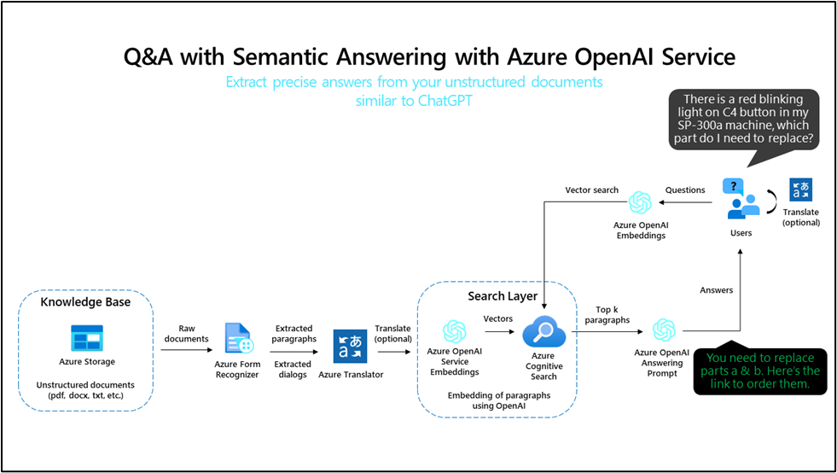

**Prerequisites**

* Before starting the Lab 08 complete the Lab 01 - Provisioning Azure OpenAI resource.

**Objectives**

* To deploy chat and embedding models in Azure AI Studio.
* To use a custom template for deploying the required resources such as App Service, Search Service, Form recognizer, etc.
* To deploy aoaichatsearch-site Web App and perform Azure OpenAI-enabled document search, text summarization, and conversation data extraction.
* To delete the deployed resources and models.

**Task 1: Deploy the Chat model and Embedding model**

1. Open your browser, navigate to the address bar, and type or paste the following URL: **https://oai.azure.com/** then press the **Enter** button.

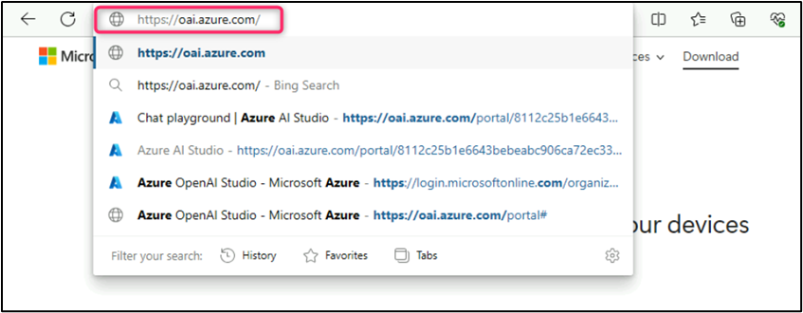

**Note**: If you are directed to the **Azure OpenAI Studio** home page, then skip steps #2 to #4, else continue.

1. In the **Microsoft Azure** window, enter your **Sign-in** credentials, and click on the **Next** button.

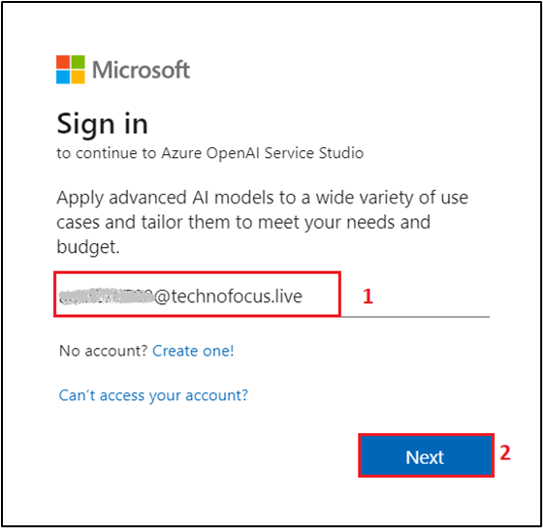

1. Then, enter the password and click on the **Sign in** button.

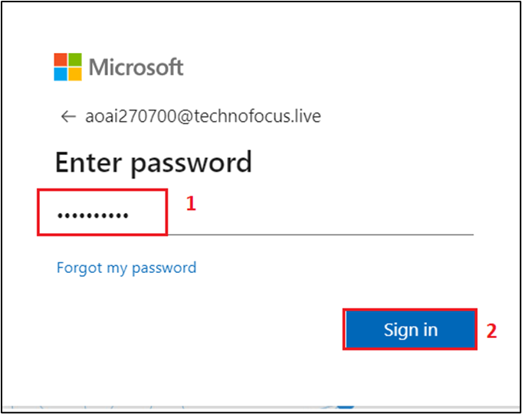

1. In **Stay signed in?** window, click on the **Yes** button.

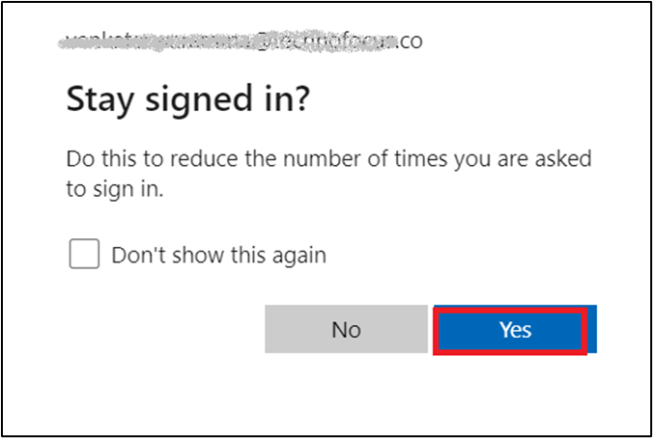

1. On the **Welcome to Azure OpenAI Studio** dialog box, under the **Subscription** field, enter the subscription assigned to you, [and in the **Resource** field, select the Resource name that you've created in Lab #1, and then]{.mark} click on the **Use resource** button.

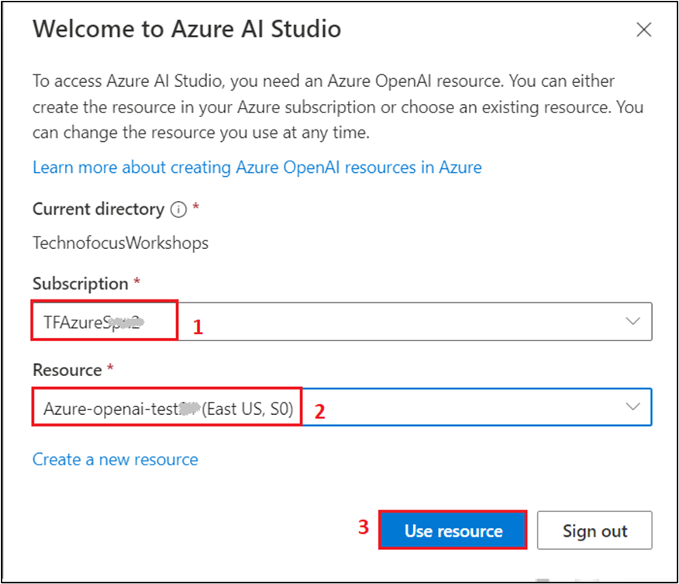

1. Wait for the Azure OpenAI studio to launch.

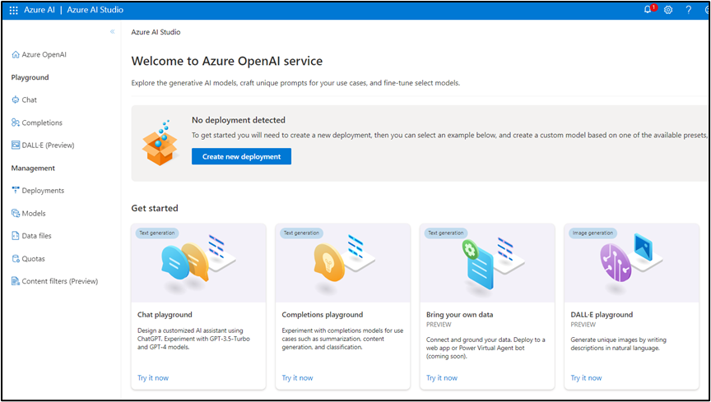

1. On the **Azure OpenAI Studio** homepage, click on **Create new deployment** button.

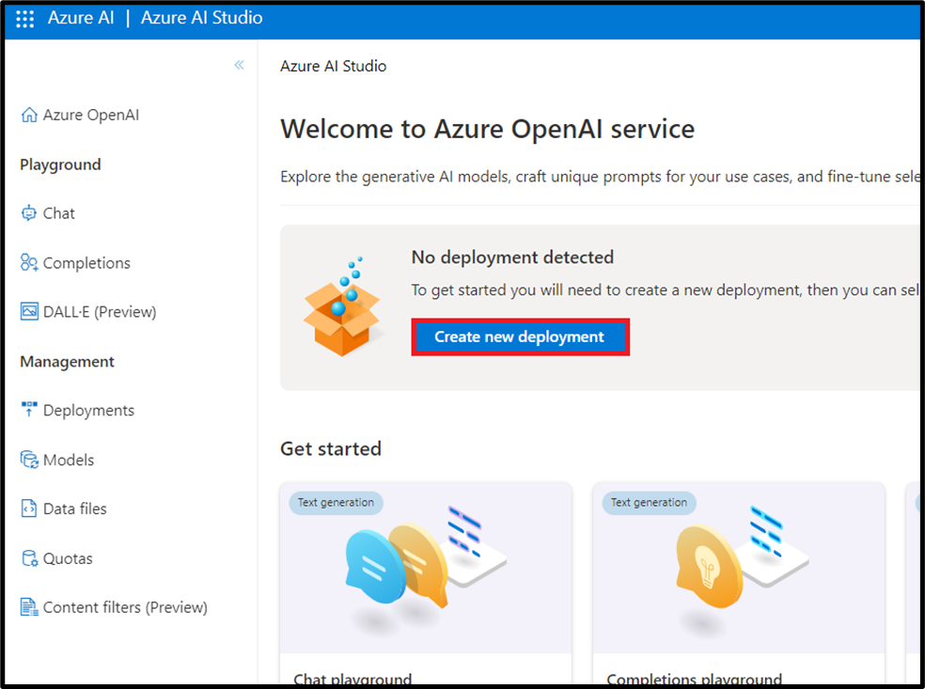

1. In the **Deployments** page, click on +**Create new deployment**.

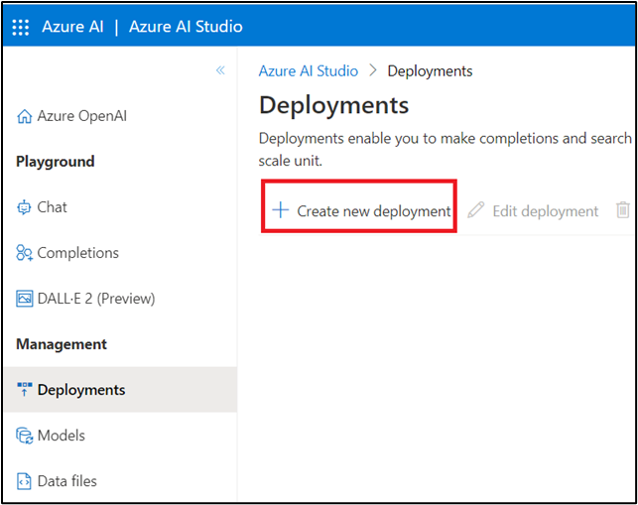

1. In the **Deploy model dialog** box, under the **Model name** field, click on the V chevron button; navigate and select carefully **gpt-35-turbo**.

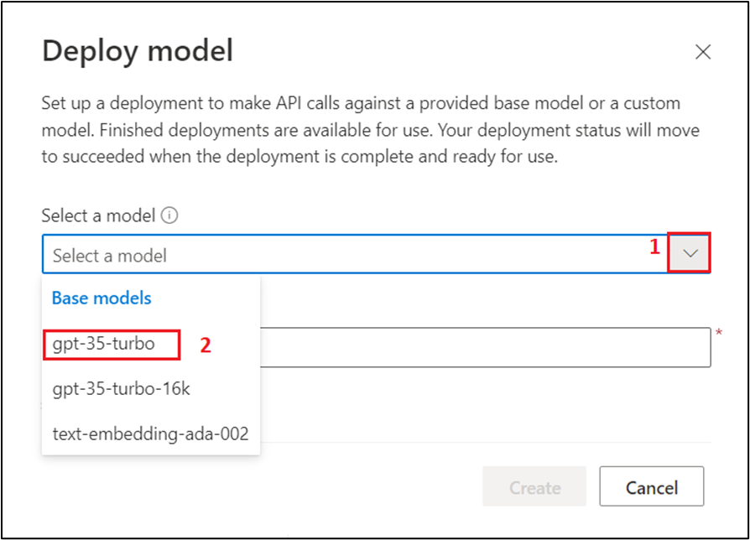

1. Select the **Model version** as **Auto-update to default,** in the **Deployment name field**, enter **gpt-35-turbo**, and click on the **Create** button.

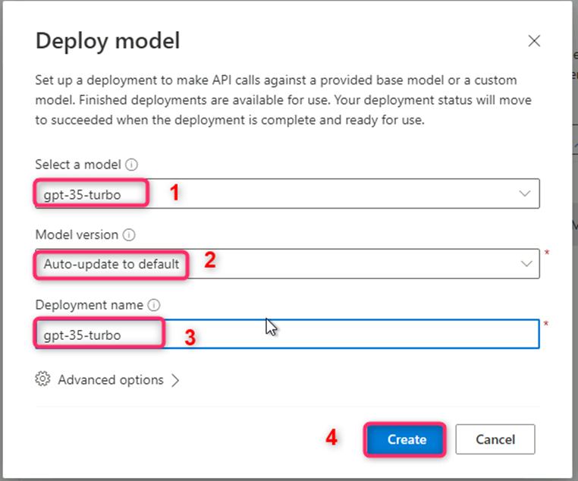

**Note:** Azure OpenAI includes multiple models, each optimized for a different balance of capabilities and performance. In this exercise, you’ll use the **GPT-3.5-Turbo** model, which is a good general model for summarizing and generating natural language and code. For more information about the available models in Azure OpenAI, see [Models](https://learn.microsoft.com/azure/cognitive-services/openai/concepts/models) in the Azure OpenAI documentation.

1. You will see a notification -- **Successfully Created deployment** when the deployment is succeeded. (You can also view the notification by clicking on the bell icon beside **Azure AI | Azure AI Studio**).

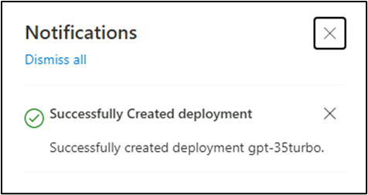

1. In the **Deployments** page, click on +**Create new deployment**.

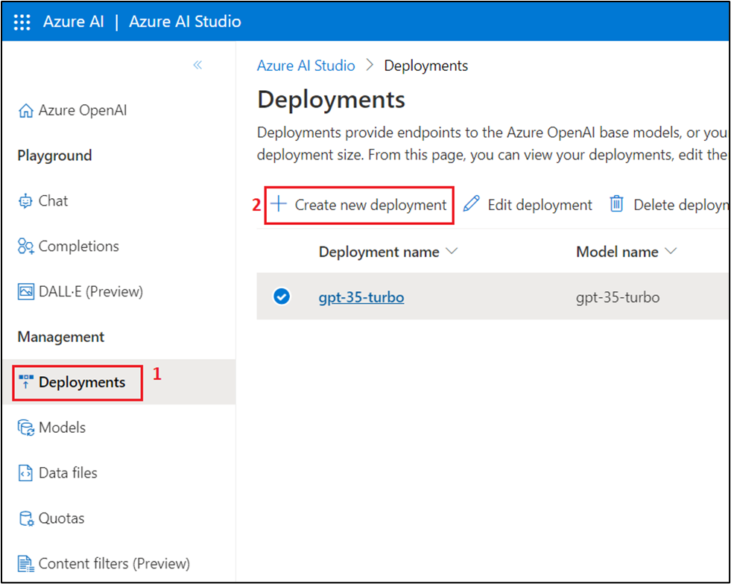

1. In the **Deploy model dialog** box, under the **Model name** field, click on the V chevron button; navigate and carefully select **text-embedding-ada-002**. Select the **Model version** as **2 (Default),** in the **Deployment name field**, enter **text-embedding-ada-002**, and click on the **Create** button.

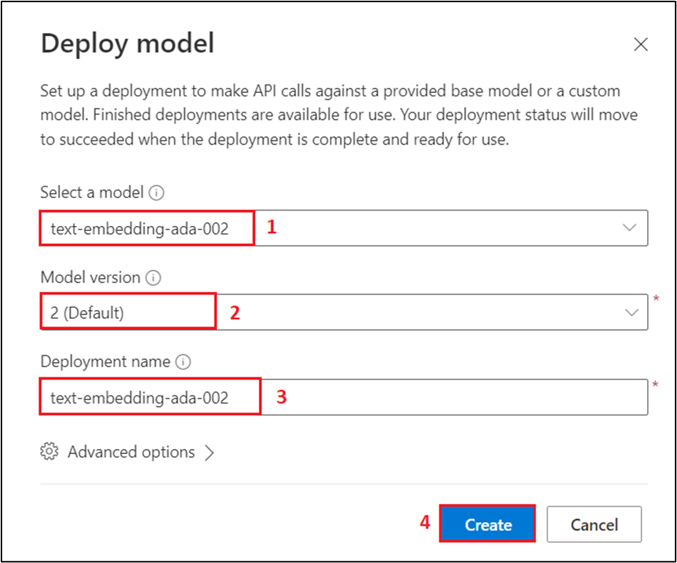

1. You will see a notification -- **Successfully Created deployment** when the deployment is succeeded. (You can also view the notification by clicking on the bell icon beside **Azure AI | Azure AI Studio**).

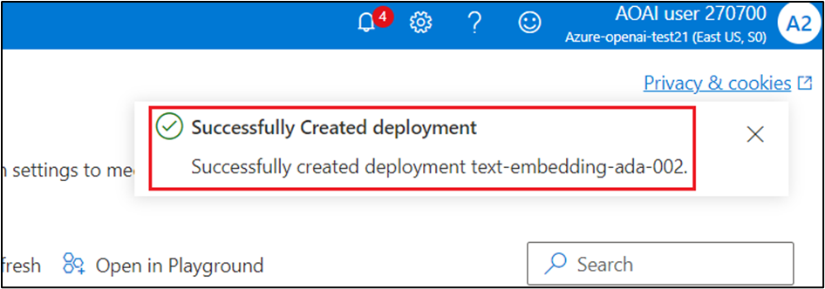

**Task 2: Deploy on Azure (WebApp + Batch Processing) with Azure Cognitive Search**

1. Open your edge browser, navigate to the address bar, and type or paste the following URL: **https://portal.azure.com/#create/Microsoft.Template/uri/https%3A%2F%2Fraw.githubusercontent.com%2Fruoccofabrizio%2Fazure-open-ai-embeddings-qna%2Fmain%2Finfrastructure%2Fdeployment_ACS.json** then press the **Enter** button.

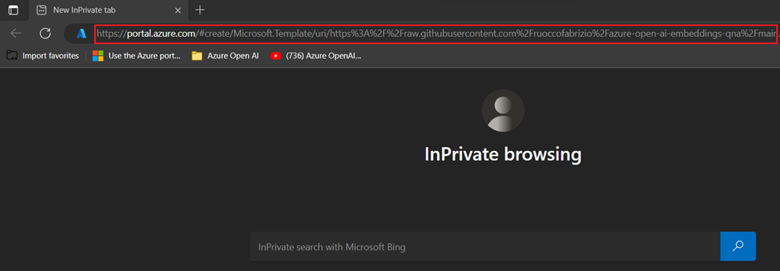

1. On **Custom deployment** window, under the **Basics** tab, enter the following details to deploy the custom template and then click on **Review + create.**

| **Subscription** | **Select the assigned subscription** |
| --- | --- |
| **Resource group** | Select your Resource group(that you have created in **Lab 1**) |
| Under Instance details **Resource Prefix** | **aoaichatsearch**(can be a unique name) |
| **Azure Cognitive Search Sku** | Basic |
| **Hosting plan Sku** | B1 |
| **OpenAI Name** | Enter your OpenAI name that you have created in Lab1 (here, we entered Azure-openai-test21) |
| **OpenAI Key** | Enter your OpenAI key that you have saved in your notepad in Lab 1-Task2 |
| **Open AI Engine** | **gpt-35-turbo** |
| **Open AI Deployment Type** | **Chat** |
| **Open AI Embeddings Engine Doc** | text-embeddeding-ada-002 |
| **Open AI Embeddings Engine Query** | text-embeddeding-ada-002 |

1. 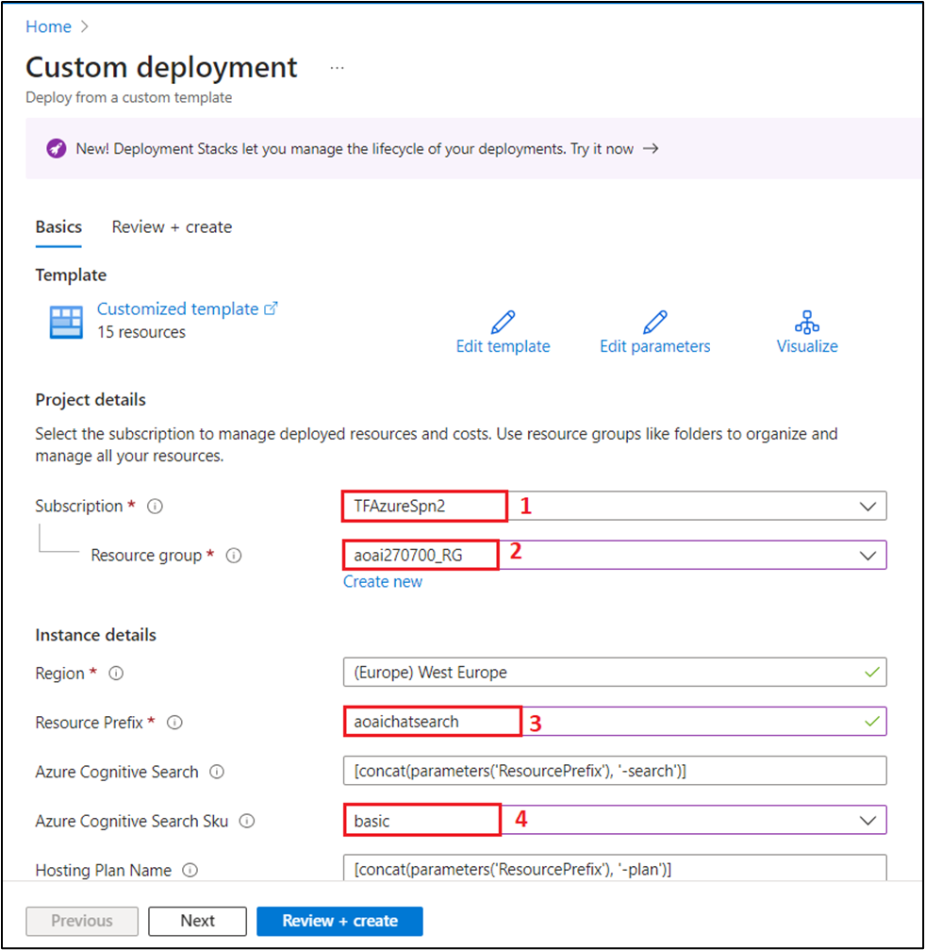
2. 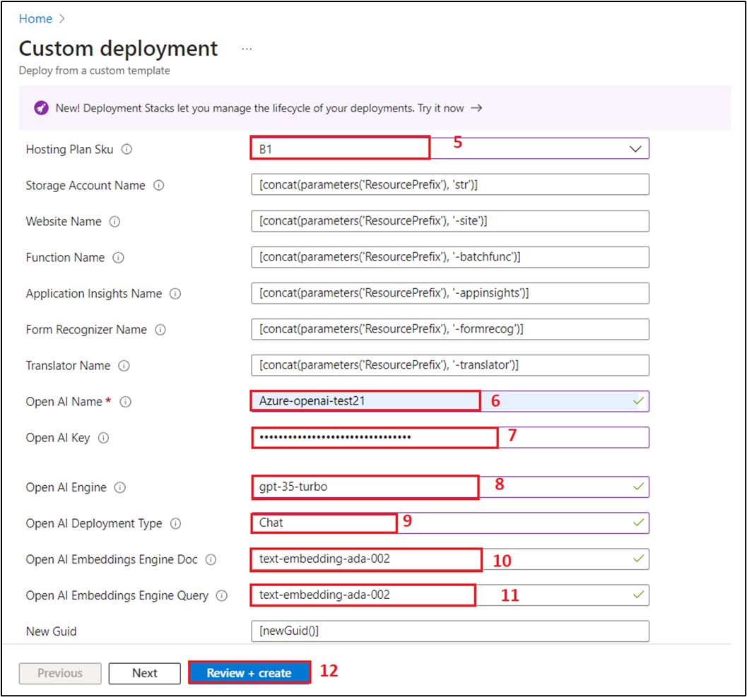
3. On **Review + create** tab, once the Validation is Passed, click on the **Create** button.

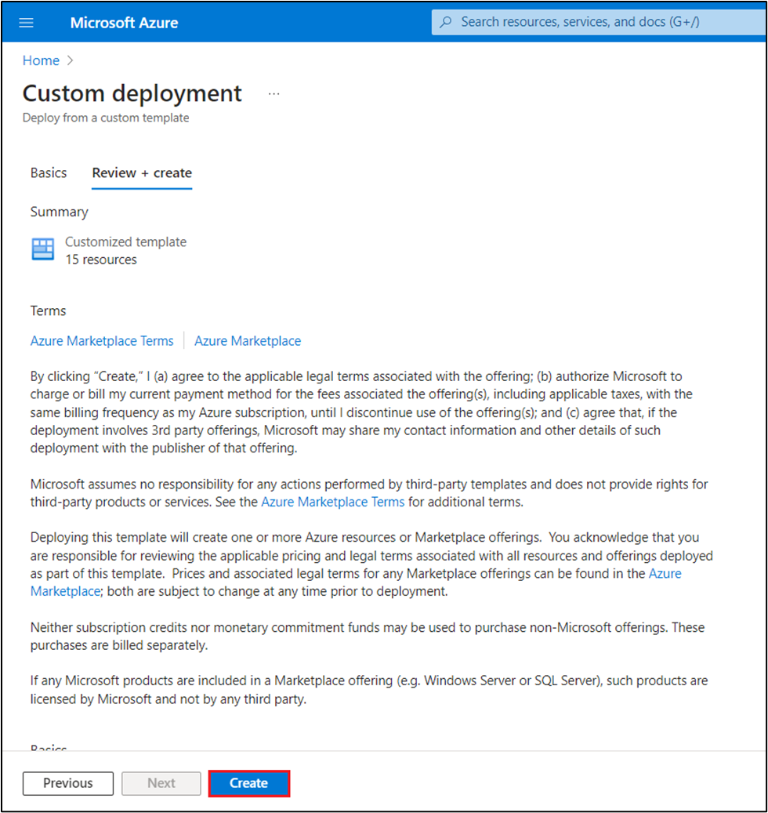

1. Wait for the deployment to complete. The deployment will take around 15-17 minutes.

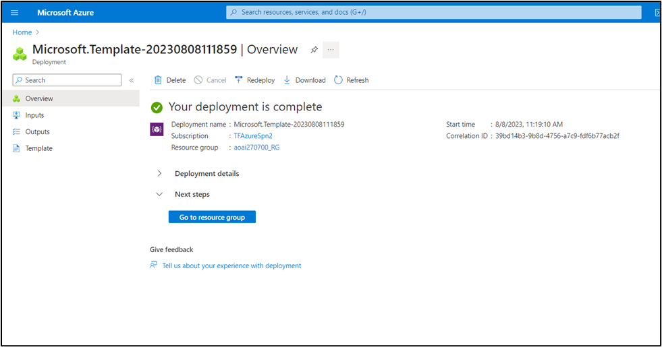

1. Click on the **Go to resource group** button.

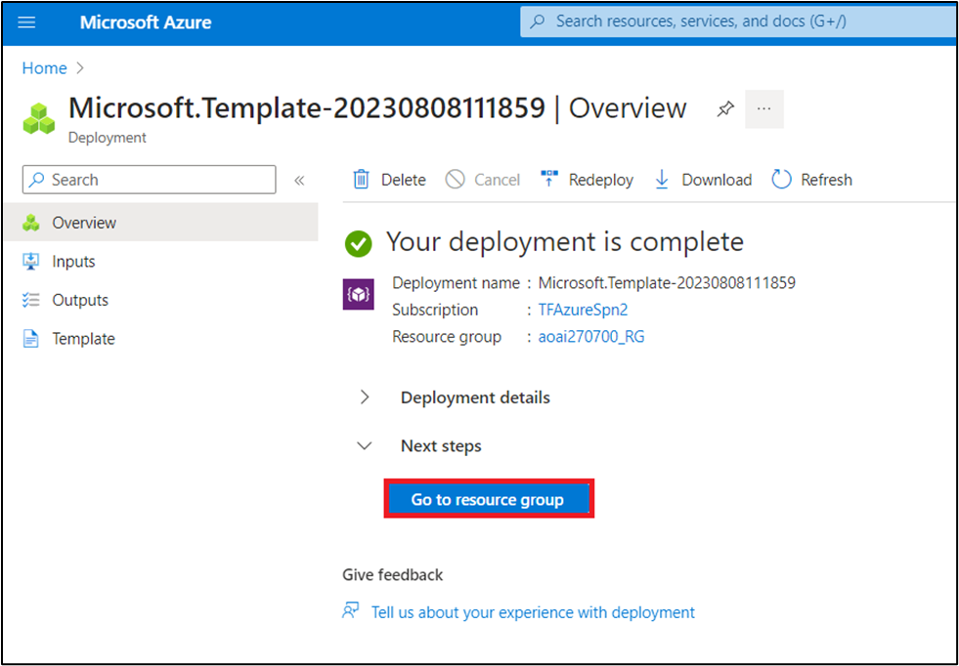

**Task 3: Azure OpenAI-enabled document search through web application**

1. On the **aoaiXXX-RG** resource group window, under **Resources** tab, navigate to the **App Service** - **aoaaichatsearch-site** and click on it.

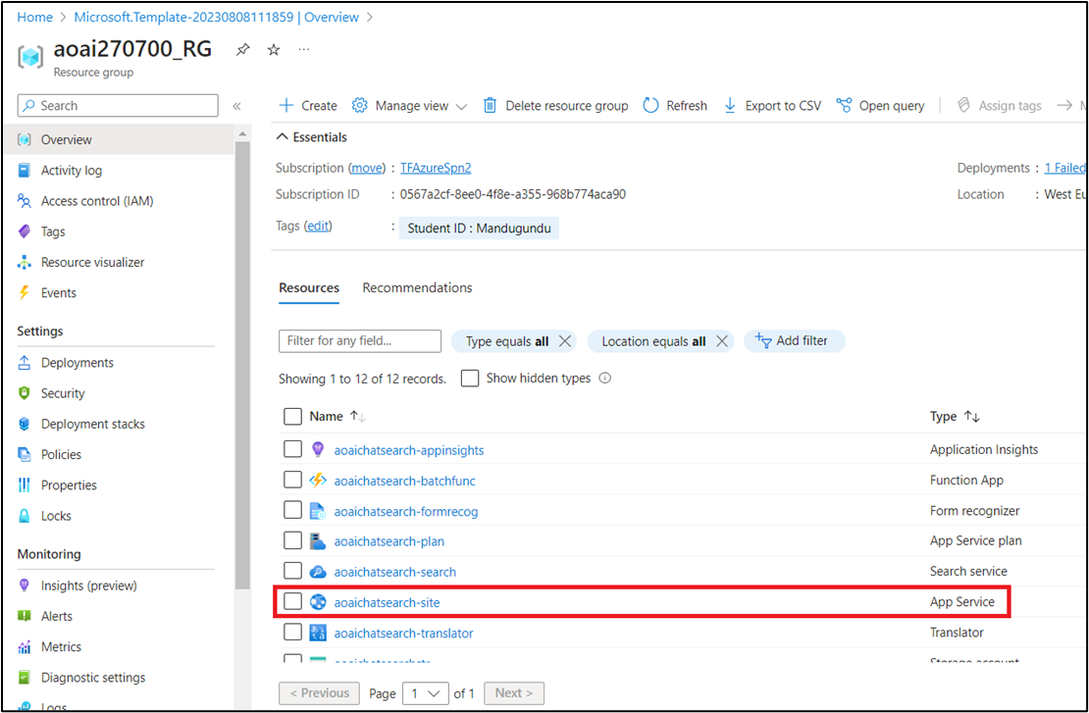

1. On **aoaichatsearch-site** Web App **Overview** page, navigate to the command bar and click on **Browse**, it will navigate you to the web application.

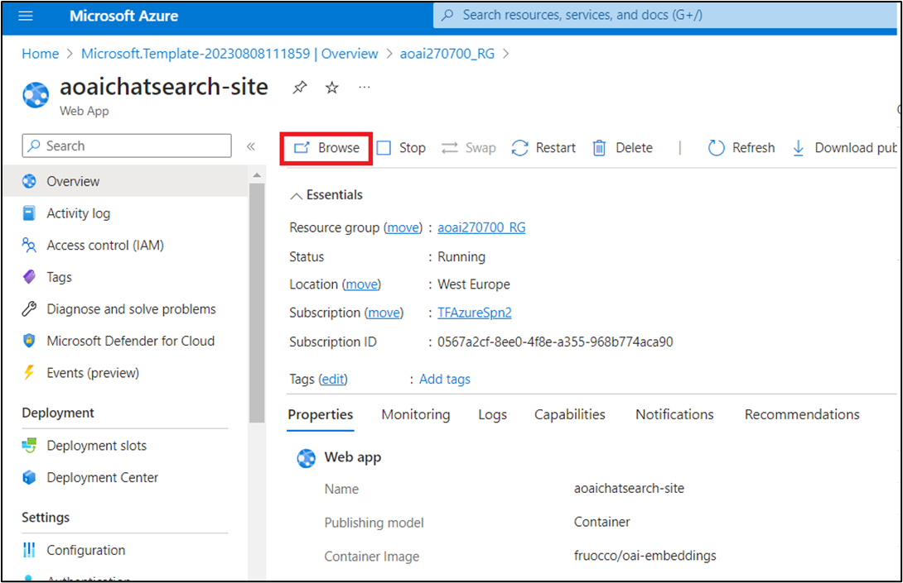

1. Wait for the web application deployment to complete. The deployment will take approximately **10-15** minutes.

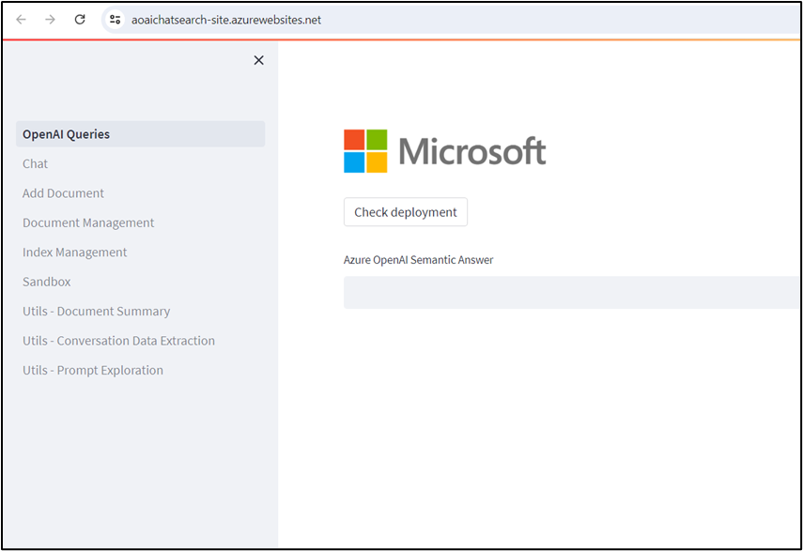

1. On the web application home page, to verify the deployments status click on the **Check deployments** button under Microsoft.

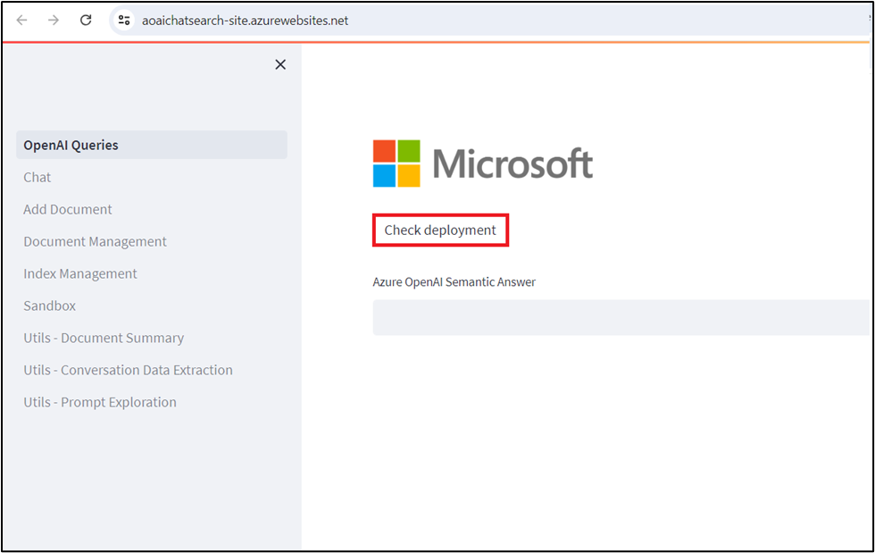

1. To check the deployment status, it may take around 5-6 min.

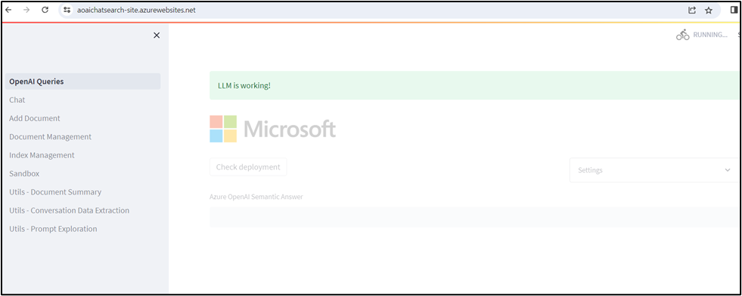

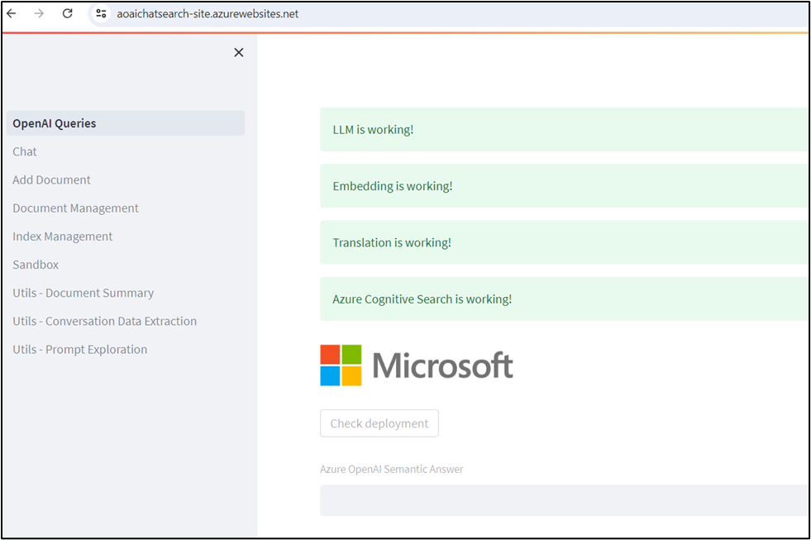

1. On Web App home page, navigate and click on **Add Document** on the left-hand side to add the data.

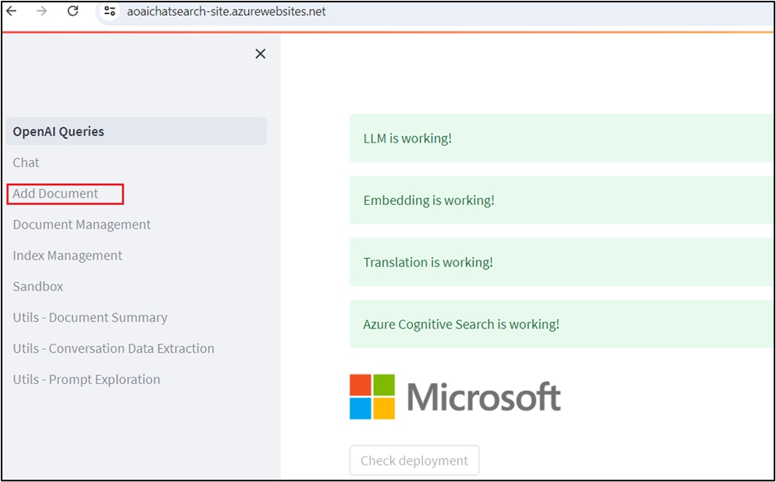

1. On **Add Document** pane, click on the **Browse files** button to upload documents that needs to be added to the knowledge base.

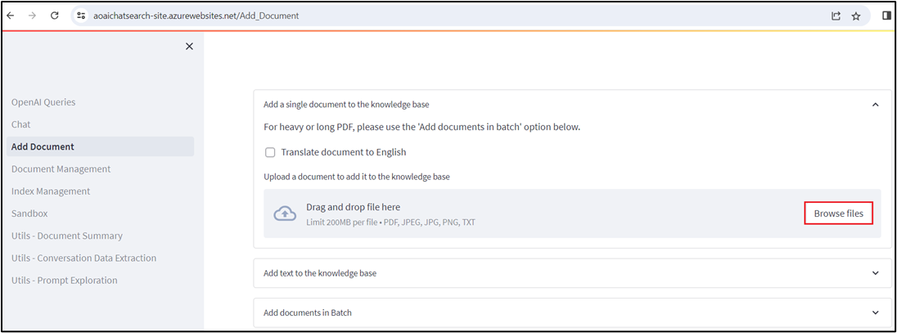

1. Navigate to **C:\Labfiles\Contoso Electronics** location in the VM and select **Benefit_Options.pdf,** then click on **Open** button.

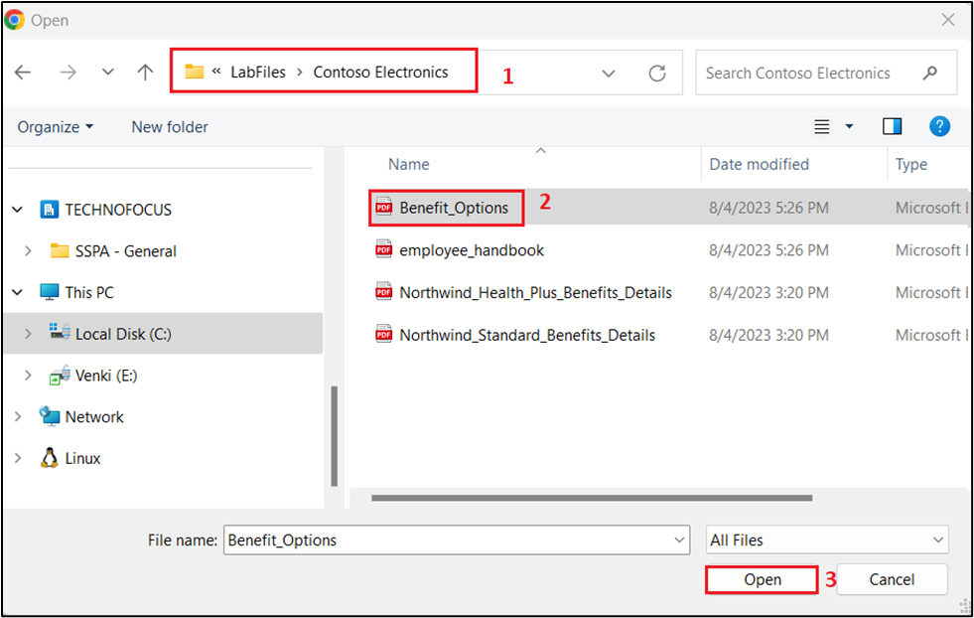

1. Click again on the **Browse files,** navigate to **C:\Labfiles\Contoso Electronics** location in the VM and select **employee_handbook.pdf**, then click on **Open** button.

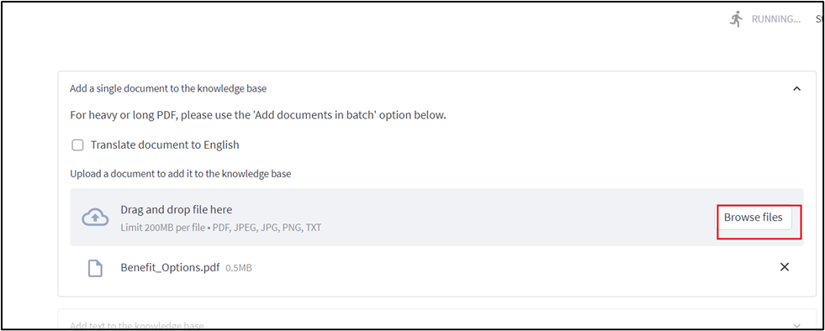

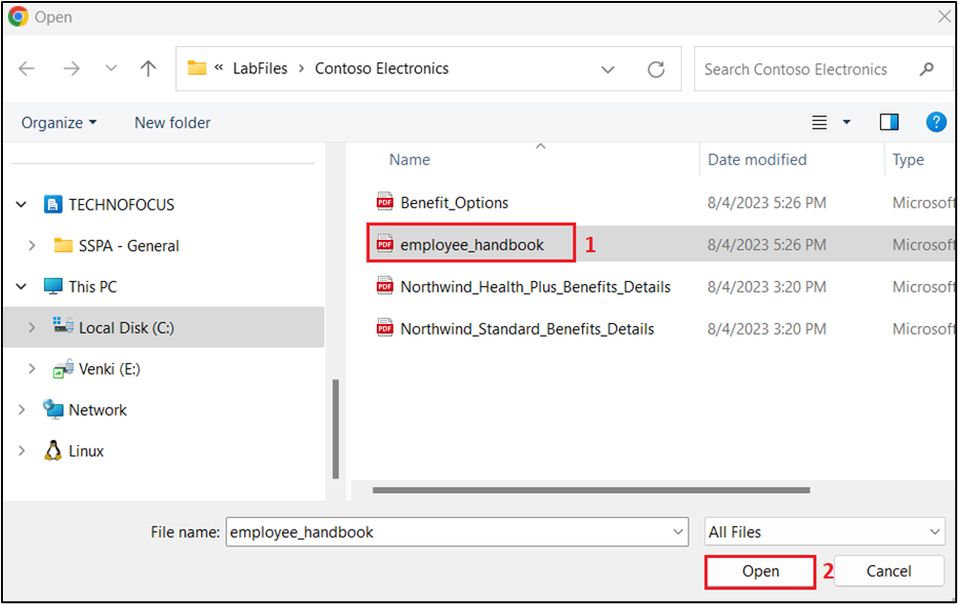

1. Similarly, add **Northwind_Health_Plus_Benefits_Details.pdf** and **Northwind_Standard_Benefits_Details.pdf**

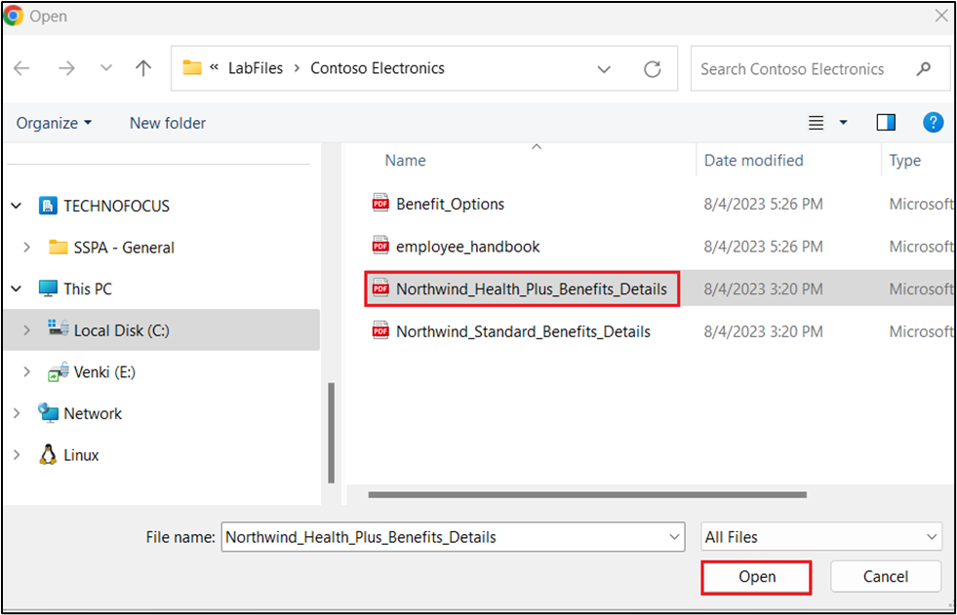

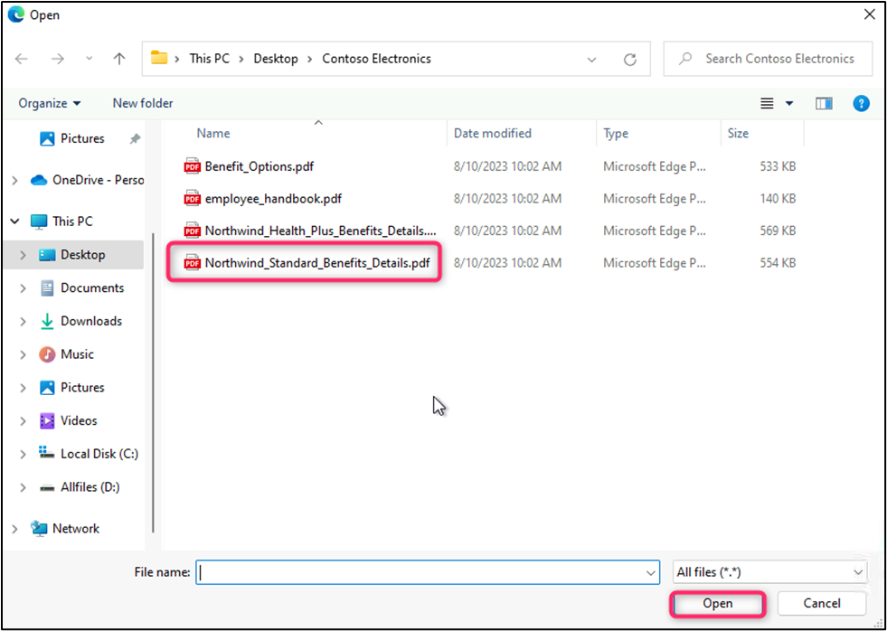

1. The uploaded data will be added to the knowledge base and it'll take approximately 5-7 minutes.
2. Click on **Document Management** to verify whether the files are successfully uploaded or not.

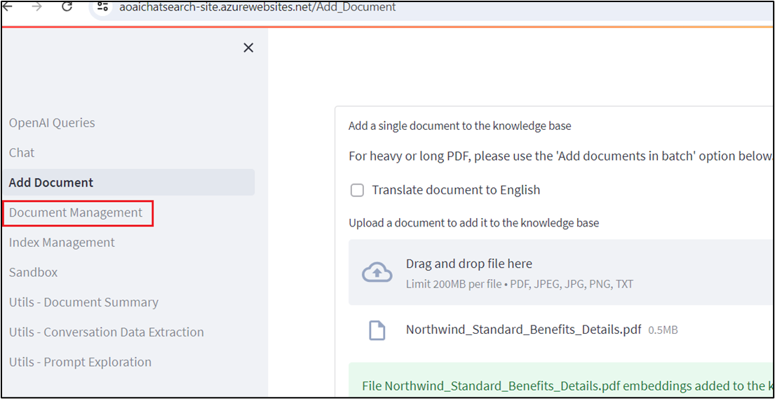

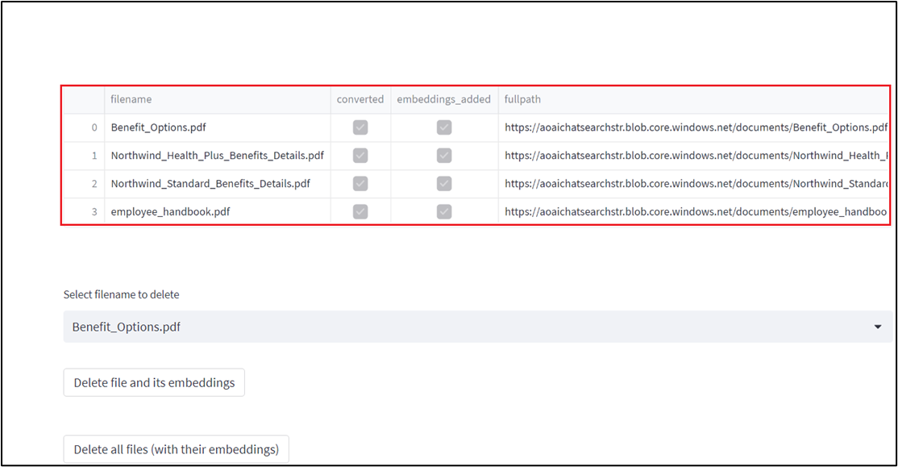

1. Click on **Index Management** to verify the files, keys, and source.

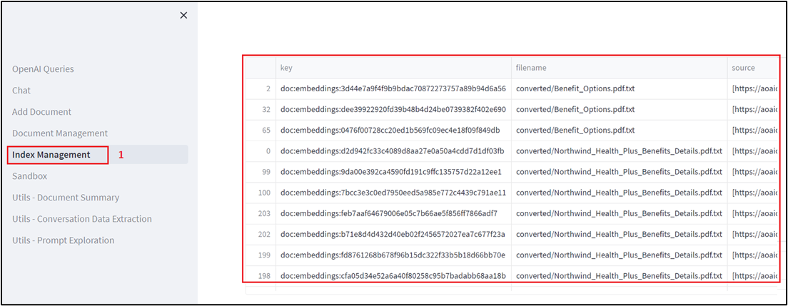

1. Then, click on **Chat.**

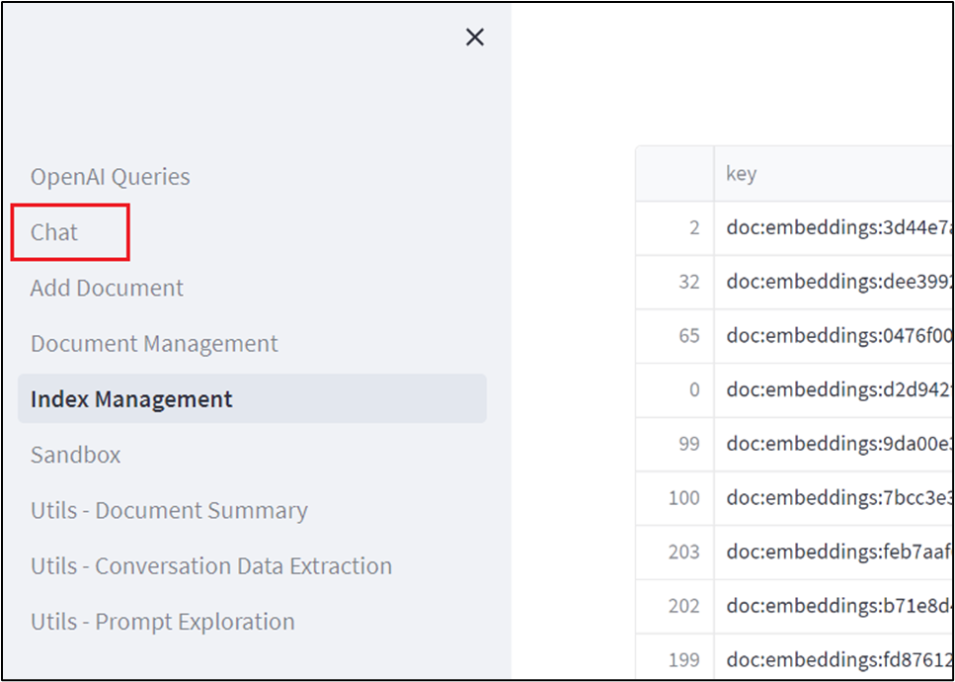

1. In the **Chat session** section, enter the following prompt, then press the **Enter** button and view the response.

**You: what is the employee's portion of the healthcare cost from each paycheck in Contoso Electronics**

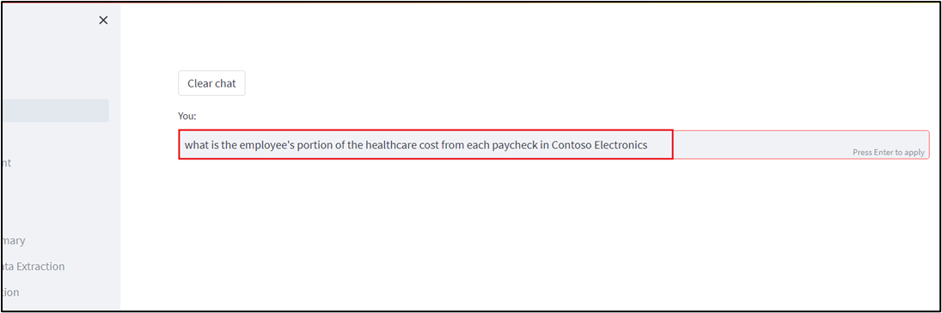

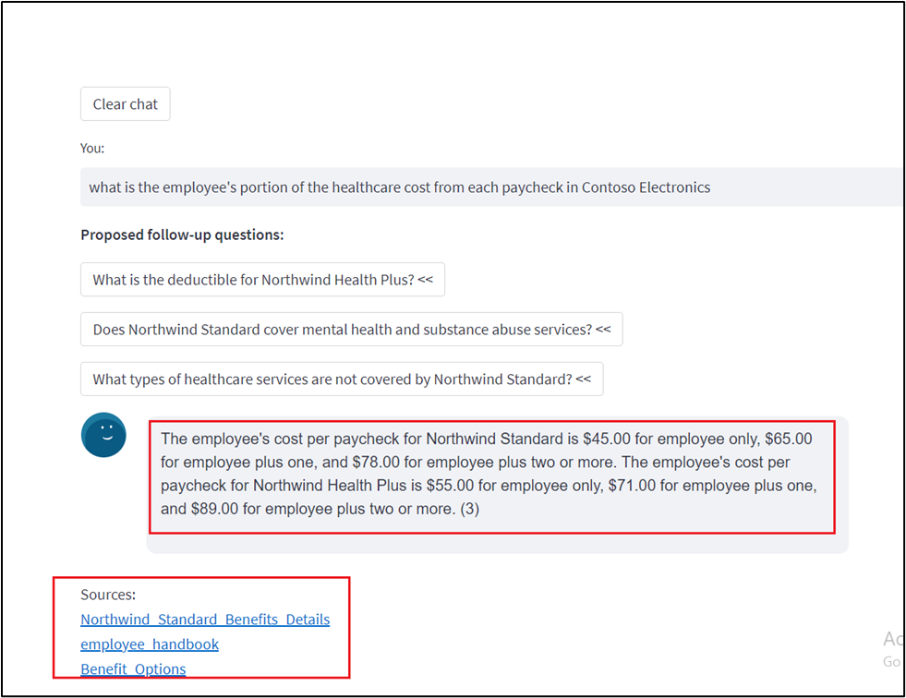

1. In the **Chat session** section, click on the **Clear chat** button.

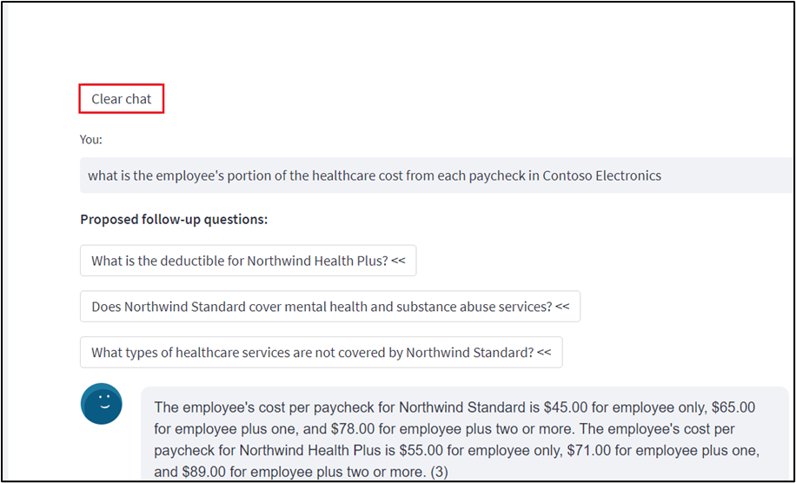

1. In the **Chat session** section, enter the following prompt, then press the **Enter** button and view the response.

**You: How do I file a complaint or appeal with Northwind Health Plus?**

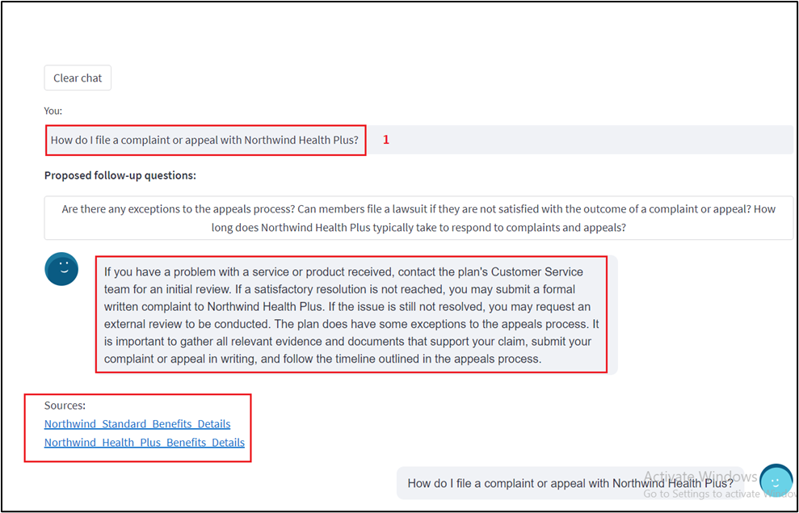

1. In the **Chat session** section, click on the **Clear chat** button.

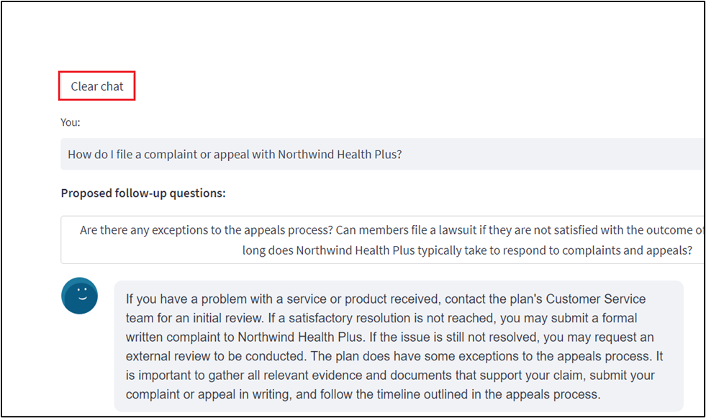

1. In the **Chat session** section, enter the following prompt. then press the **Enter** button and view the response.

**You: Does my plan covers my eye exams?**

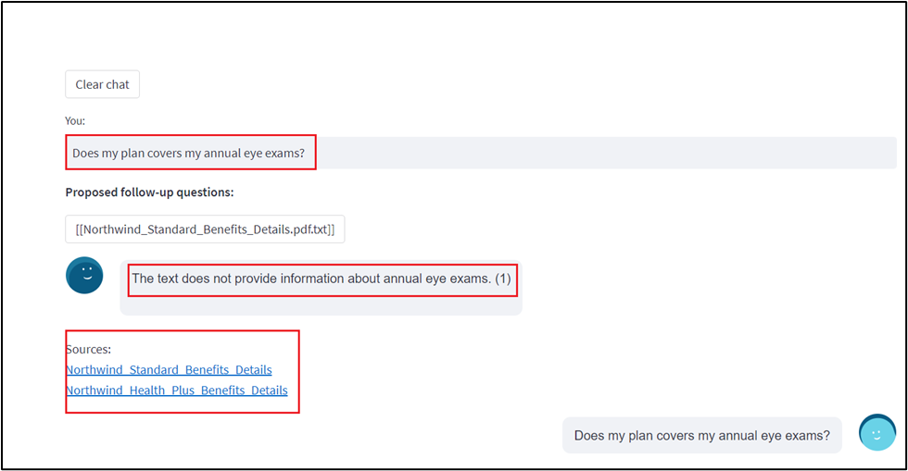

1. Click on **Utils-Document Summary** on the left-hand side.

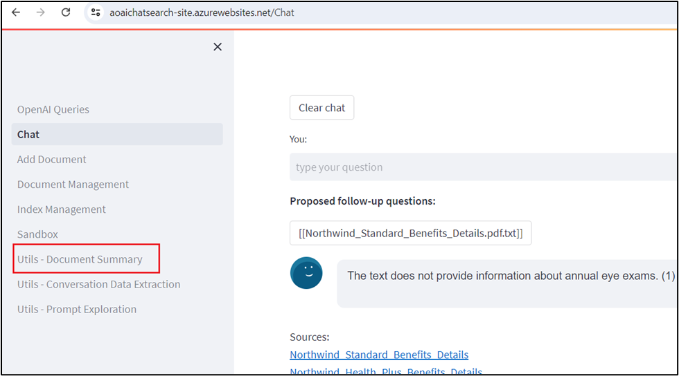

1. In the **Summarization** section, select the **Basic Summary** radio button**.**

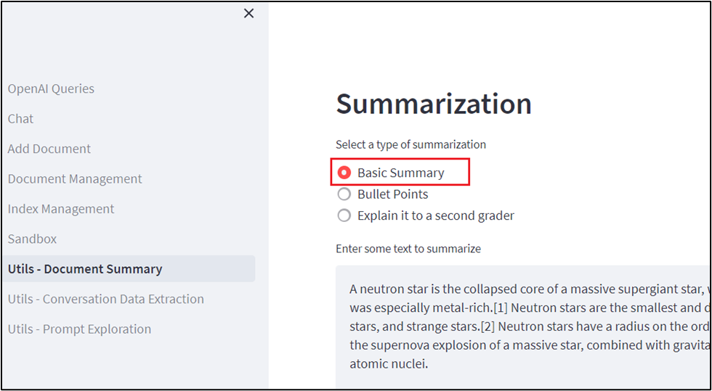

1. In the **Summarization** window, under **Enter some text to summarize** section, in the message box, replace the current text with the following, then click on the **Summarize** button.
2. It's been six months since we reinvented search with the new
3. AI-powered Bing and Edge.
4. In that short time, you've engaged in so many unique and creative ways;
5. to date we've seen over 1 billion chats and over 750 million images fill
6. the world of Bing! We've also seen nine consecutive quarters of growth
7. on Edge, meaning we're more able than ever to bring our best-in-class AI

experiences to users across the web.

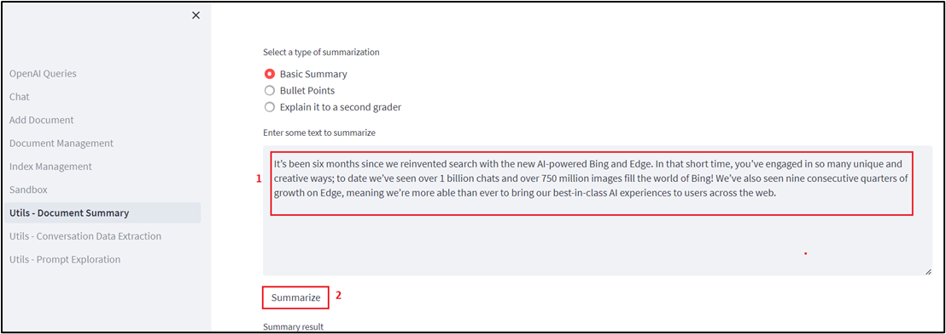

1. Check the summary of the text that you've entered.

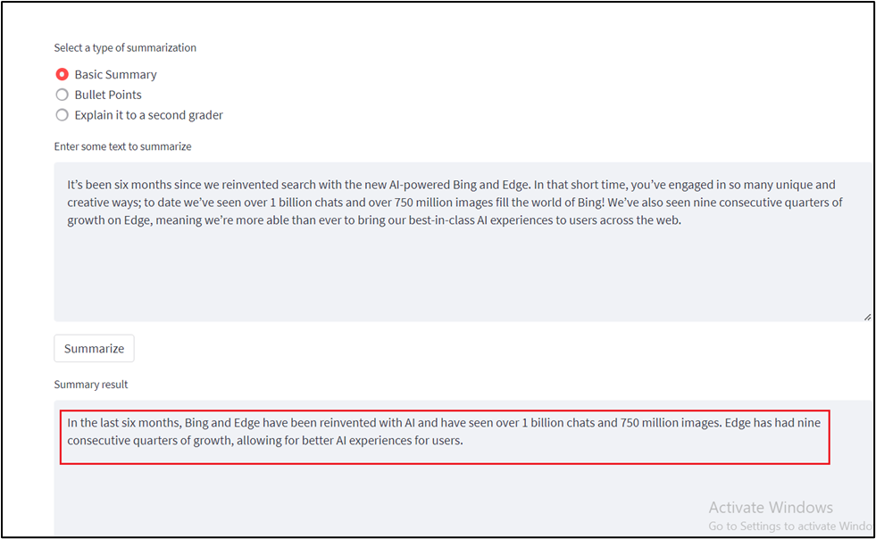

1. After reviewing the Summary result, click on the **Clear summary** button.

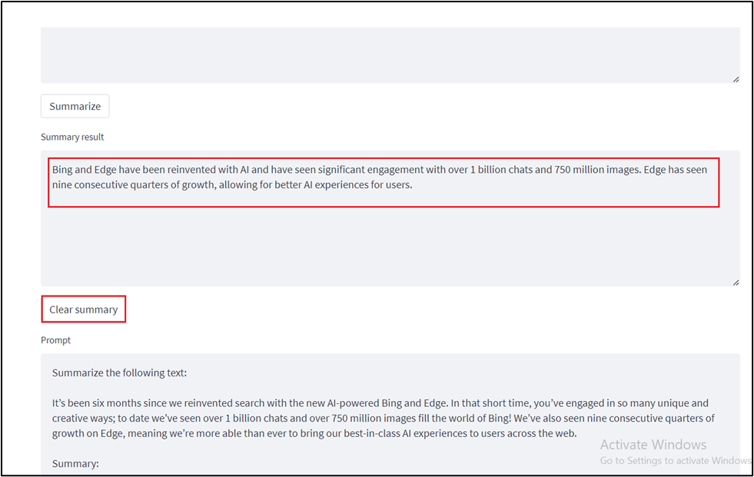

1. Now, scroll up and select the **Bullet Points** radio button. Under **Enter some text to summarize** section, in the message box, replace the current text with the following and then click on the **Summarize** button.
2. Microsoft has made its Azure OpenAI Service generally available,
3. bringing the enterprise generative AI tools out of its invite-only
4. program. Now any customers who meet Microsoft's standards can access the
5. professional versions of OpenAI's large language model GPT-3.5 and the
6. related text-to-image tool DALL-E 2, computer programming assistant
7. Codex, and the popular ChatGPT chatbot interface for the LLM.
8. Microsoft launched the Azure OpenAI Service with an eye toward offering
9. businesses a way to develop apps without coding, write reports, and put
10. together marketing content. The scope has grown since then to encompass
11. new facets of the OpenAI's models, including chat and visuals. Those
12. interested in the tools have to explain how they will use the AI tools
13. and agree to Microsoft's ethical guidelines in their application for
14. access. The decision to widen the Azure OpenAI Service's availability
15. arrives in tandem with Microsoft's plans to integrate ChatGPT and DALL-E
16. into its Office suite, Bing search engine, and other consumer products.
17. Azure OpenAI Service followed earlier experiments to integrate GPT-3
18. into Microsoft projects like the low-code Power Apps programming tool

and the GitHub Copilot programming assistant.

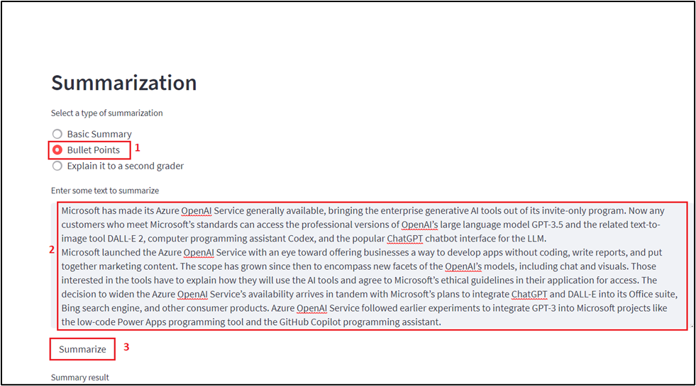

1. You'll see the summary results in the form of bullet points.

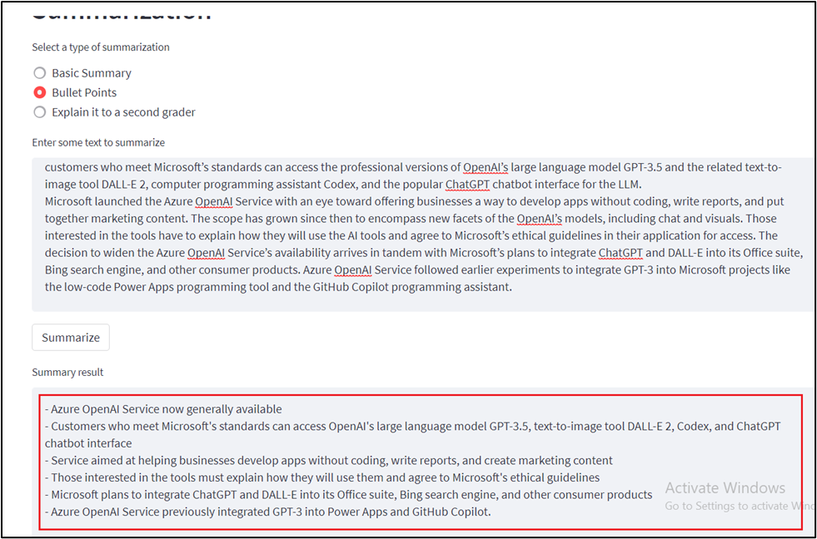

1. Click on **Utils-Conversation Data Extraction** on the left side.

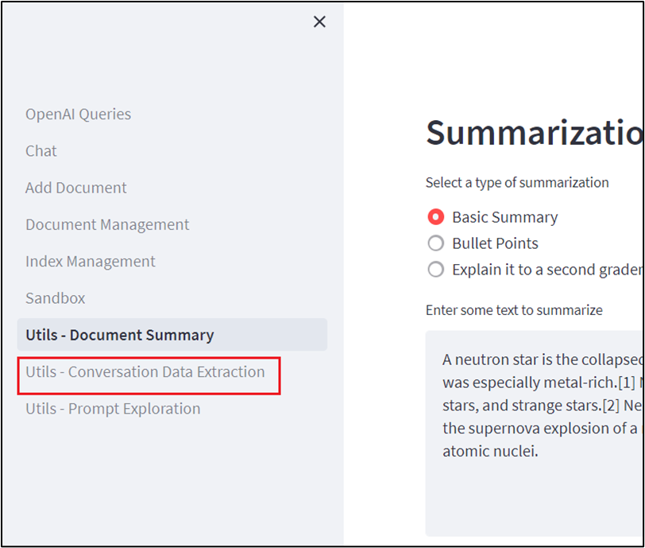

1. On the **Conversation data extraction** pane, click on the **Execute tasks** and view the response under **OpenAI result**.

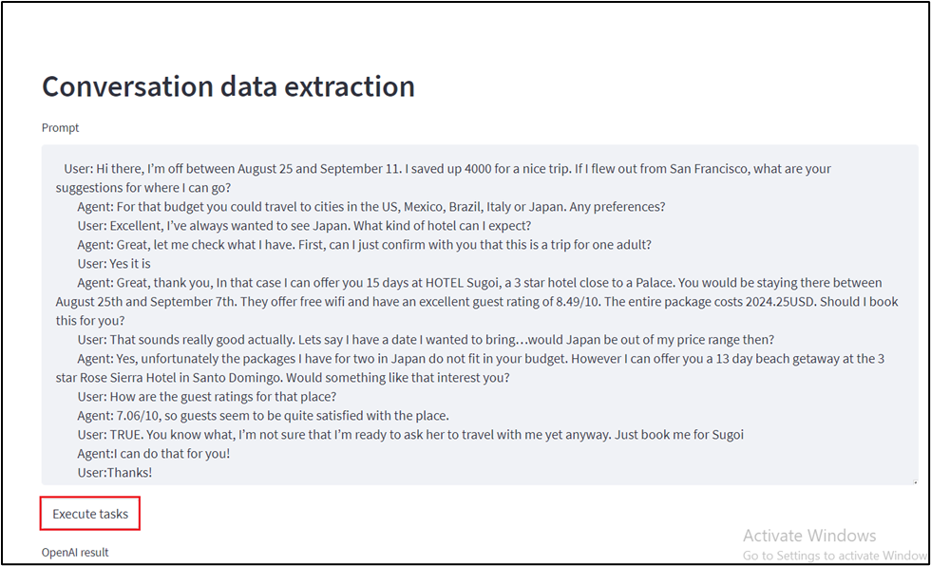

1. Review the data extracted from the conversation between the Agent and the User.

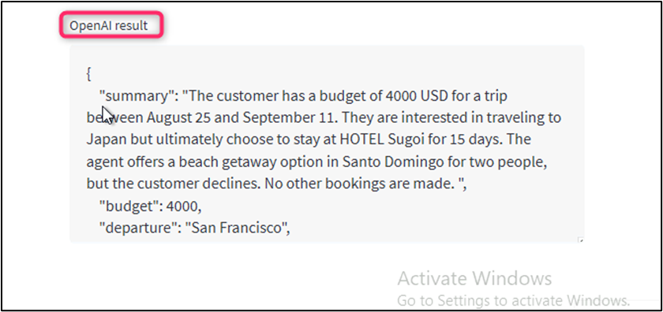

**Task 4: Deleting the deployed resources and models**

1. To delete the deployed resources, navigate to **Azure portal home** page, click on **Resource groups**.

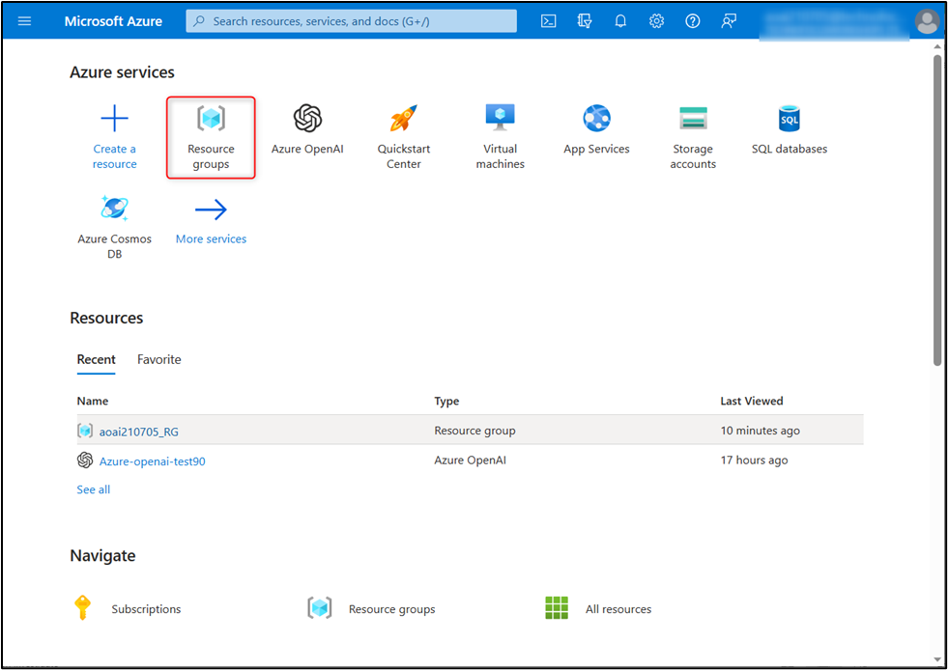

1. Click on the assigned resource group.

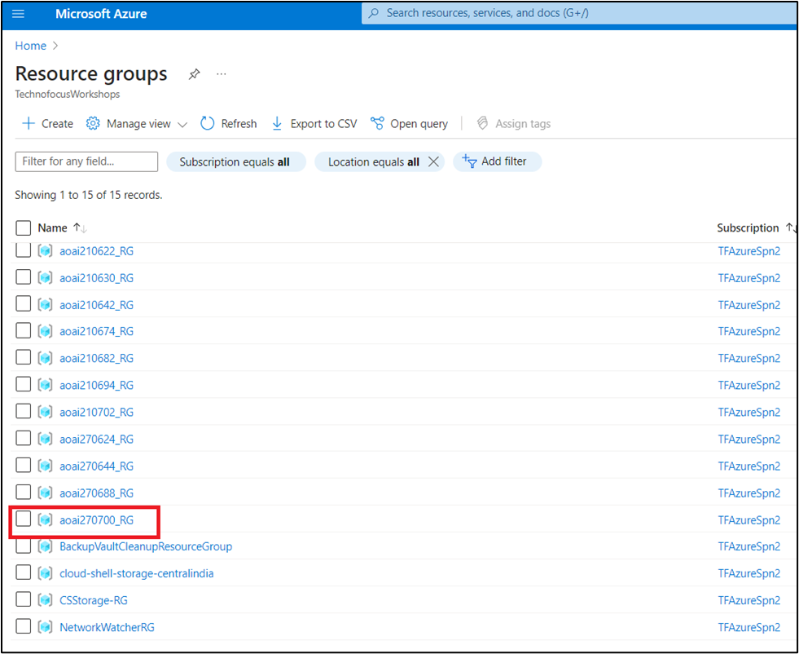

1. Select all the deployed resources except **Azure OpenAI Service**.

**Important Note:** Please do not select and delete the **Azure OpenAI Service** (Azure-openai-testXX), as the same service will be used in other labs.

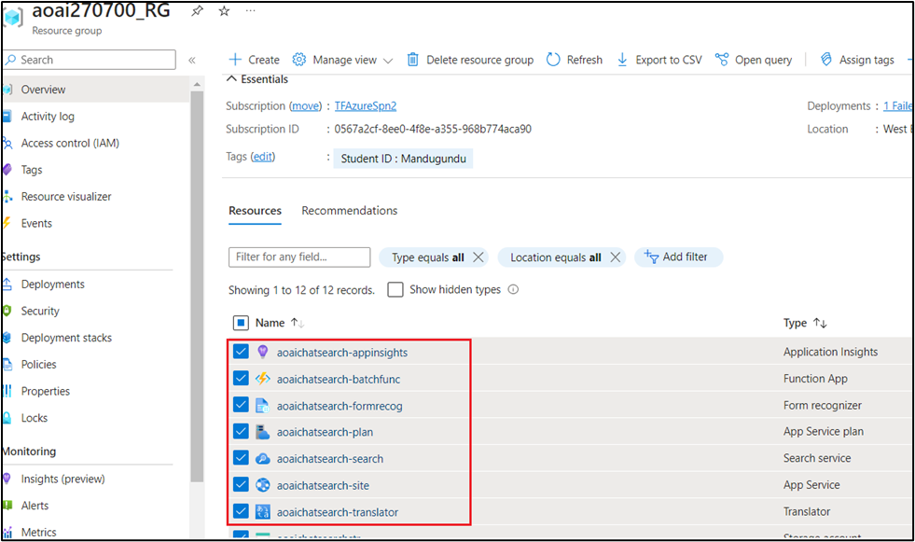

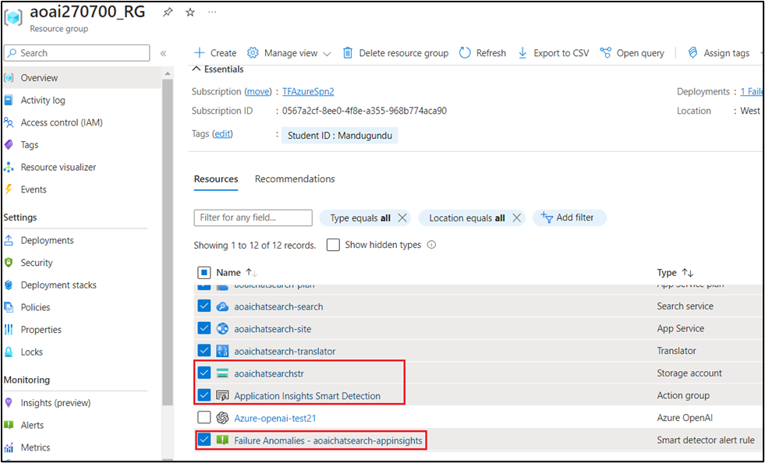

1. In the Resource group page, navigate to command bar and click on **Delete**.

**Note**: Don't click on **Delete resource group**. If you don't see the **Delete** option in the command bar, the click on the horizontal ellipsis, then navigate and click on **Delete**.

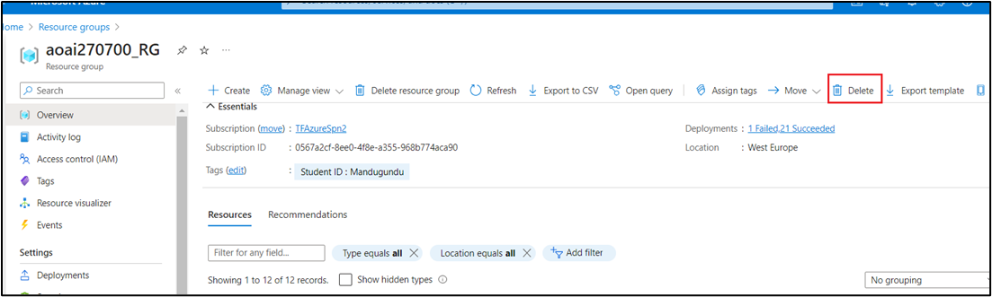

1. In the **Delete Resources** pane that appears on the right side, enter the **delete** and click on **Delete** button.

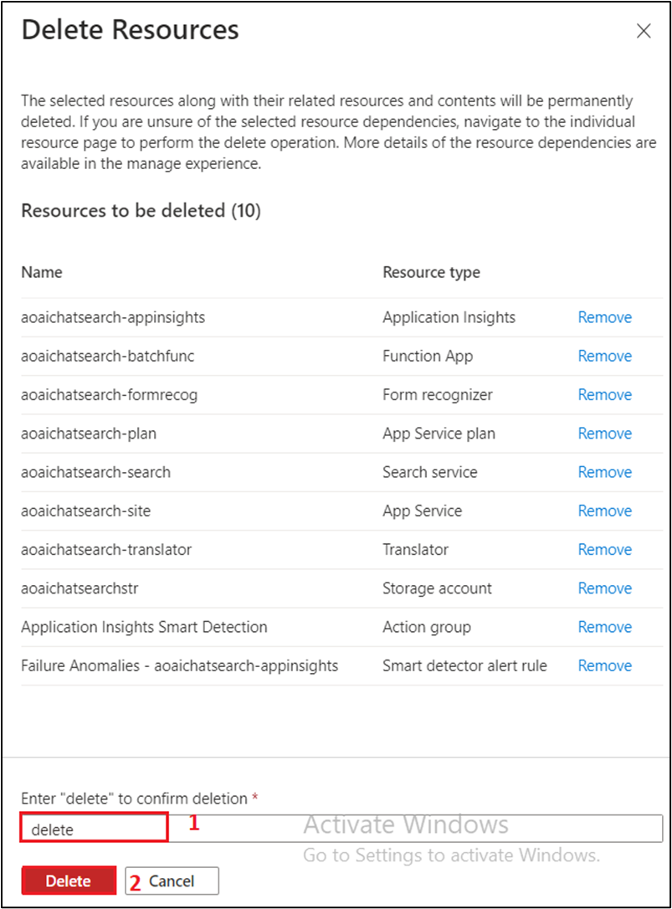

1. On **Delete confirmation** dialog box, click on D**elete** button.

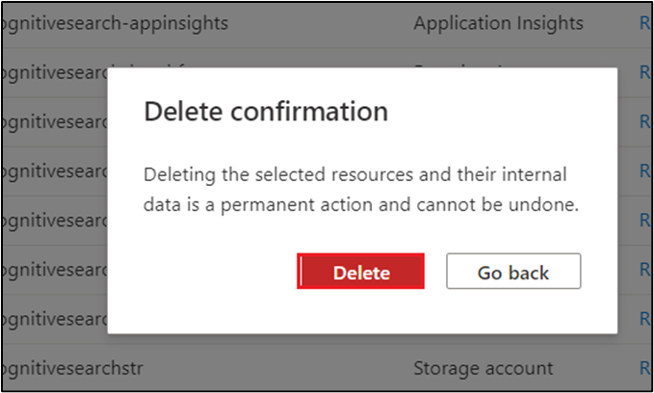

1. Click on the bell icon, you'll see the notification -- **Executed delete command on 10 selected items.**

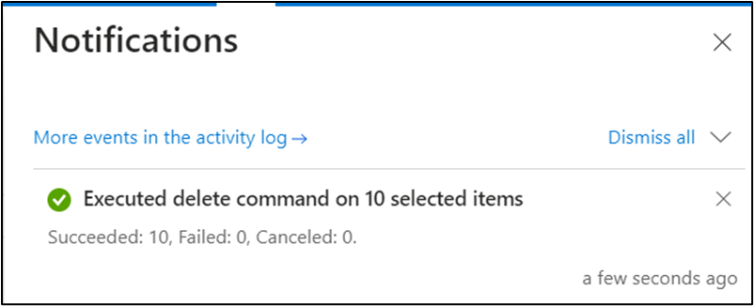

1. In **Azure AI Studio** page, click on **Deployments** on the left side navigation menu, then select **text-embedding-ada-002 model** and click on **Delete deployment** in the command bar.

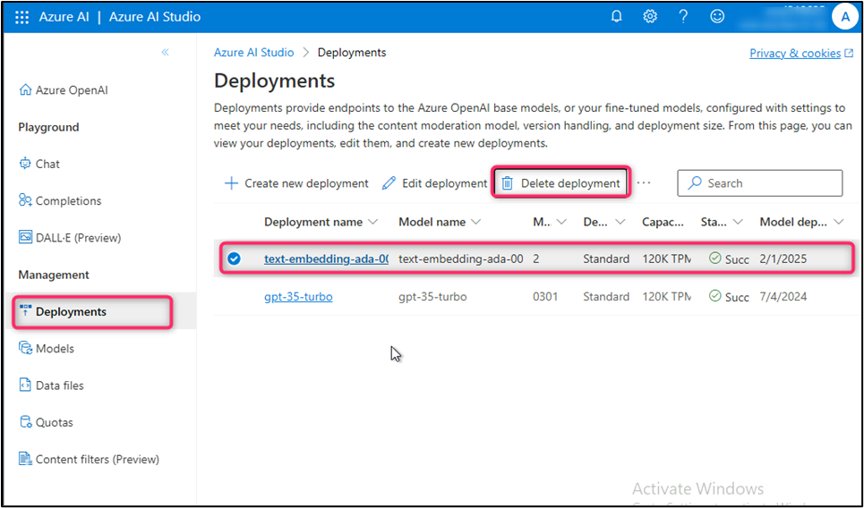

1. On **Confirm delete** dialog box, click on **Delete** button.

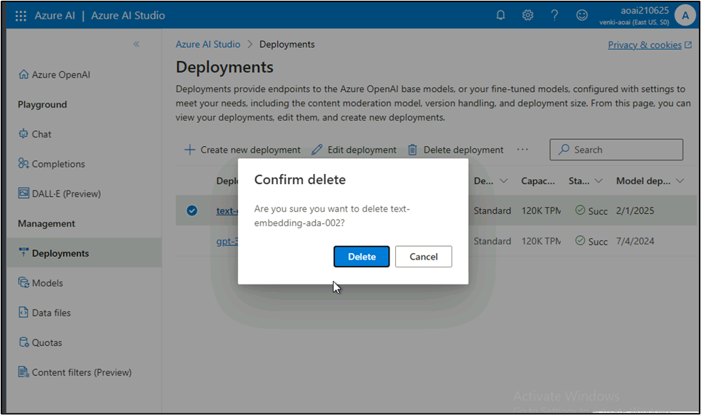

1. You'll receive a notification stating -- **Successfully Deleted deployment text-embedding-ada-002.**

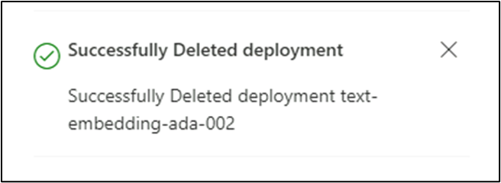

1. Similarly, delete **gpt-35-turbo model**.

**Summary**

You've deployed gpt-35-turbo chat model and text-embedding-ada-002 embedding model in your Azure AI Studio, then you've deployed the necessary resources using a custom template. You've uploaded unstructured documents in aoaichatsearch-site Web App and extracted the precise information in a chat session. You've generated basic as well as bullet points summary from sample texts, then you've extracted the data from a conversation. At the end of the lab, you've deleted the resources and models to efficiently manage your Azure OpenAI resources.

**Important Note: Please do not delete the Resource group and Azure OpenAI Service (Azure-openai-testXX). The same Resource group and AOAI service will be used throughout all the labs.**